Using SSMS to generate TSQL Create and Insert Scripts

Tips and Hints:

You can use **SQL Servers – Using SSMS to generate TSQL Create and Insert Scripts** to help you migrate your Databases.

Note this is an alternative to the preferred option of using SSMS - Backup and Restore.

Adapted by Alexandra Groves from original by Mansha Nawaz

1. Generating SQL Create / Insert Scripts Revisited

*Generating Database Script*

To script a full database, expand Object Explorer and highlight the database name.

Right-click the database and then click Tasks>Generate Script:

In the ‘Generate and Publish Scripts’ wizard that opens, click Next.

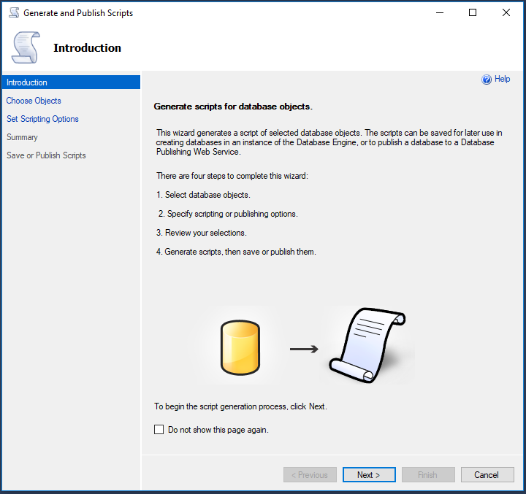

Select ‘Script entire database and all database objects’:

In the next screen, select ‘ Save to new query window’ and then click on the Advanced button:

In the ‘Advanced Scripting Options’, scroll down to ‘Types of data to script’ and then mouse click next to ‘Schema only’

Open the dropdown and select ‘Schema and data’ and then click OK.

**MN: For large databases split the files as**

* **Schema Script – Create Scripts for Tables and Relations**
* **Insert Scripts for – data**

Note – You can also cho0se which Server Version to script for:

Back in the ‘Generate and Publish Scripts’ wizard click Next:

In the ‘Review your selections’ screen, click Next again:

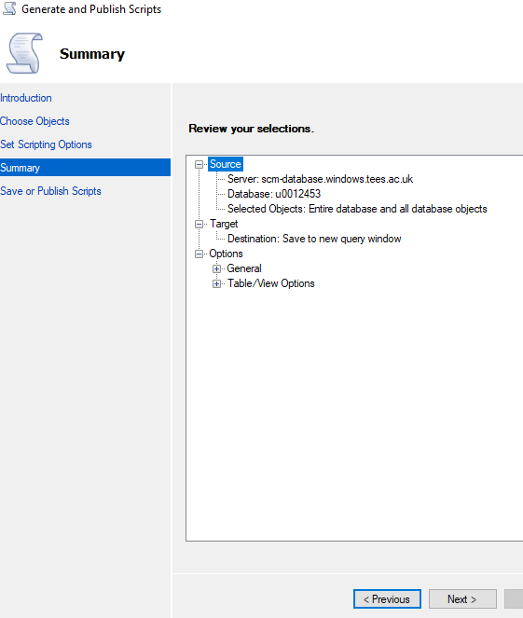

You will then see the ‘Saving or publishing scripts’ screen - click Finish:

The generated script (to recreate the database and data) will now appear in the Query Editor window:

*Moving the database between home and Uni*

To recreate the latest version of your database (at home from the Uni version or at Uni from the home version) you will need to ‘drop’ (delete) the version that is already there –BUT make sure you have generated the script (as in the instructions above) to recreate the database first!

*Dropping the existing tables*

Right click on the last table in the list and select Delete then OK in the window that appears. Work up the list of tables deleting each one. Then repeat these actions for the Schema.

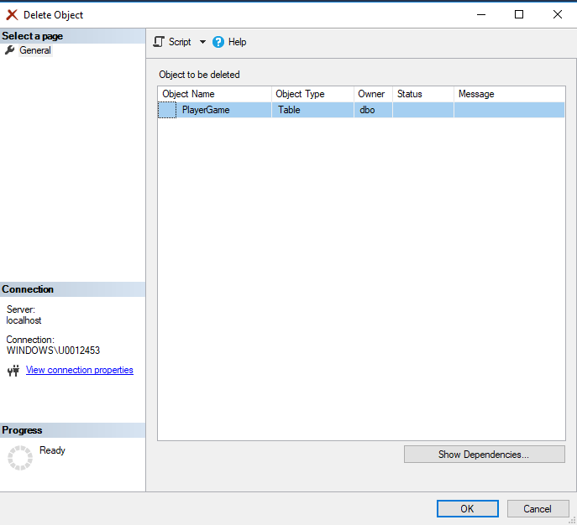

*Recreating the database on a different PC*

As long as you have deleted any old version of the Database the TSQL Create and Insert command should run successfully.

However, if it does not then the following is a manual process in using the SSMS autogenerated TSQL Create and Insert scripts.

Remember to use the preferred method of Backup and Restore – see SQL Tips on Backup and Restore.

Examine the sql code for the generated create insert script and note the initial code which creates the database. If the database exists on the host machine then an error will occur and the transaction terminated with no changes. SQL will not let you create a database if it already exists.

Solution Step 1: **Delete the original database**

1. In Object Explorer, connect to an instance of the SQL Server Database Engine, and then expand that instance.
2. Expand Databases, right-click the database to delete, and then click Delete.
3. Confirm the correct database is selected, and then click OK.

Solution Step 2:

1. Edit the Create Script code (notepad) and find the first ‘**create table**’ command and delete everything prior to this line. Save the file.
2. In Object Explorer, connect to an instance of the SQL Server Database Engine, and then expand that instance.
3. Expand Databases, right-click the database and click **New Database**. Give it a name
4. Confirm the correct database is selected, and then click OK.
5. In ObjectExplorer click on New Query and copy/paste the revised code. Click on Execute.
6. Right click the database name and click refresh
7. Expand the tables and you will see all the tables have been replicated along with the data if you also have the insert scripts
8. Note you need to recreate the Database Diagrams by adding the tables … SQL will automatically redraw the relationships for you based on the table constraints.

Original Scripting Guide by Mansha Nawaz

**MS SQL SERVER – Script a Database**

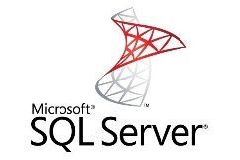

**NOTE: This is useful and quick way to replicate your database on different machines or maintain different development versions. You will find this method as the quick easy way to transfer your database between home and labs.**

# SCRIPT TABLES and DATA IN SQL SERVER

SQL Server Management Studio since 2008 has a useful tool which generates the ‘create’ scripts to replicate the tables/relationships and ‘insert’ scripts to replicate the data.

A SQL script is a set of SQL commands or T-SQL program statements saved as a file in SQL Scripts. A SQL script can contain one or more SQL statements or PL/SQL blocks. You can use SQL Scripts to create, edit, view, run, and delete from a SQL Database.

## SCRIPT TABLE DATA WITH GENERATE SCRIPTS

The **Generate Scripts** function is available via SQL Serverhttp://ir-na.amazon-adsystem.com/e/ir?t=dirkstrauss-20&l=ur2&o=1 Management Studio right

By click on your Databasehttp://ir-na.amazon-adsystem.com/e/ir?t=dirkstrauss-20&l=ur2&o=1 and select **Tasks** -> **Generate Scripts**…

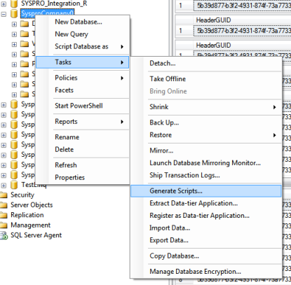

From the next window that opens, select to script the entire database or only a few objects. The example below opted to script only specific tables.

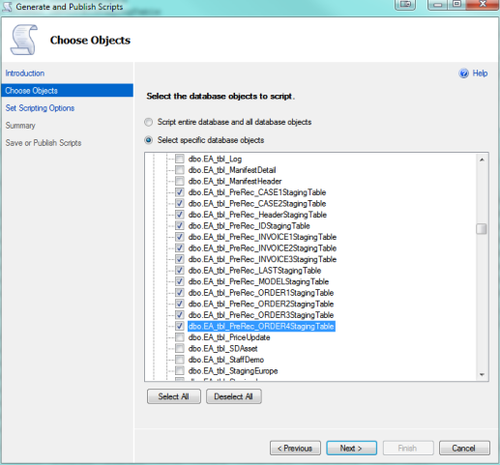

On the next screen you can define the output path if you are saving the scripts to file.

However click on the **Advanced Button** to access the Generate Script tool.

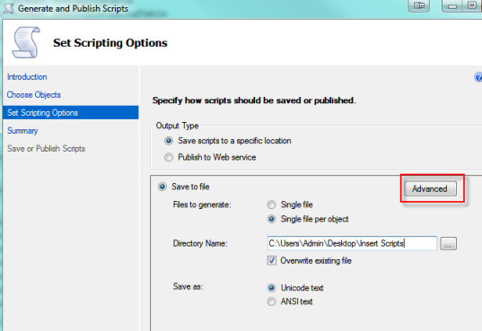

Under the General section, select the last option ‘**Types of data to script**’ and choose one of the options from the dropdown menu. For my purposes of this example only the data in the table is selected ‘**Data Only**’. You might want the schema (create commands for the tables) and data (insert commands).

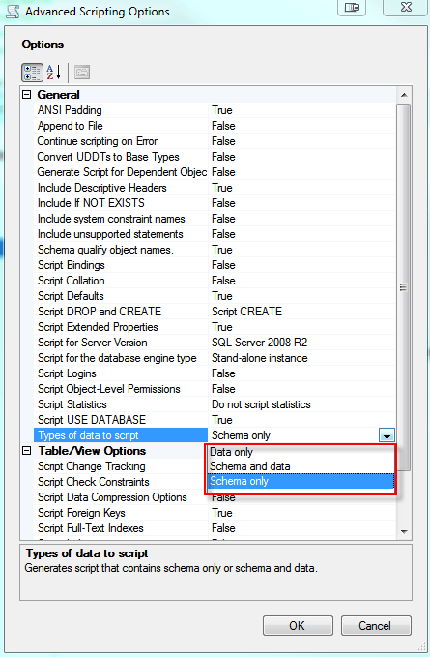

After you click ok, you can choose to script all the objects to one single file or split them up into a separate file for each object. This is obviously a decision you need to make according to your preference.

## Using the script code to replicate the database

**NOTE: This is useful and quick way to replicate your database on different machines or maintain different development versions.**

Examine the sql code for the generated create insert script and note the initial code which creates the database. If the database exists on the host machine then an error will occur and the transaction terminated with no changes. SQL will not let you create a database if it already exists.

Solution Step 1: **Delete the original database**

1. In Object Explorer, connect to an instance of the SQL Server Database Engine, and then expand that instance.
2. Expand Databases, right-click the database to delete, and then click Delete.
3. Confirm the correct database is selected, and then click OK.

Solution Step 2:

1. Edit the Create Script code (notepad) and find the first ‘**create table**’ command and delete everything prior to this line. Save the file.
2. In Object Explorer, connect to an instance of the SQL Server Database Engine, and then expand that instance.
3. Expand Databases, right-click the database and click **New Database**. Give it a name
4. Confirm the correct database is selected, and then click OK.
5. In ObjectExplorer click on New Query and copy/paste the revised code. Click on Execute.
6. Right click the database name and click refresh
7. Expand the tables and you will see all the tables have been replicated along with the data if you also have the insert scripts
8. Note you need to recreate the Database Diagrams by adding the tables … SQL will automatically redraw the relationships for you based on the table constraints.

# Generating SQL Create / Insert Scripts Revisited

**Step 1 : Generating Database Script**

To script a full database, expand Object Explorer and highlight the database name. Right-click the database and then click **Tasks:** **Generate Script.**

**Step 2 : Welcome Screen**

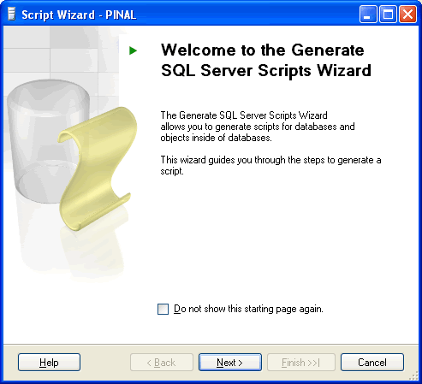

**Step 3 : Select One or Multiple Database**  
If Script all objects in the selected database checkbox is not selected it will give options to selected individual objects on respective screen. (e.g. Stored Procedure, Triggers and all other object will have their own screen where they can be selected)

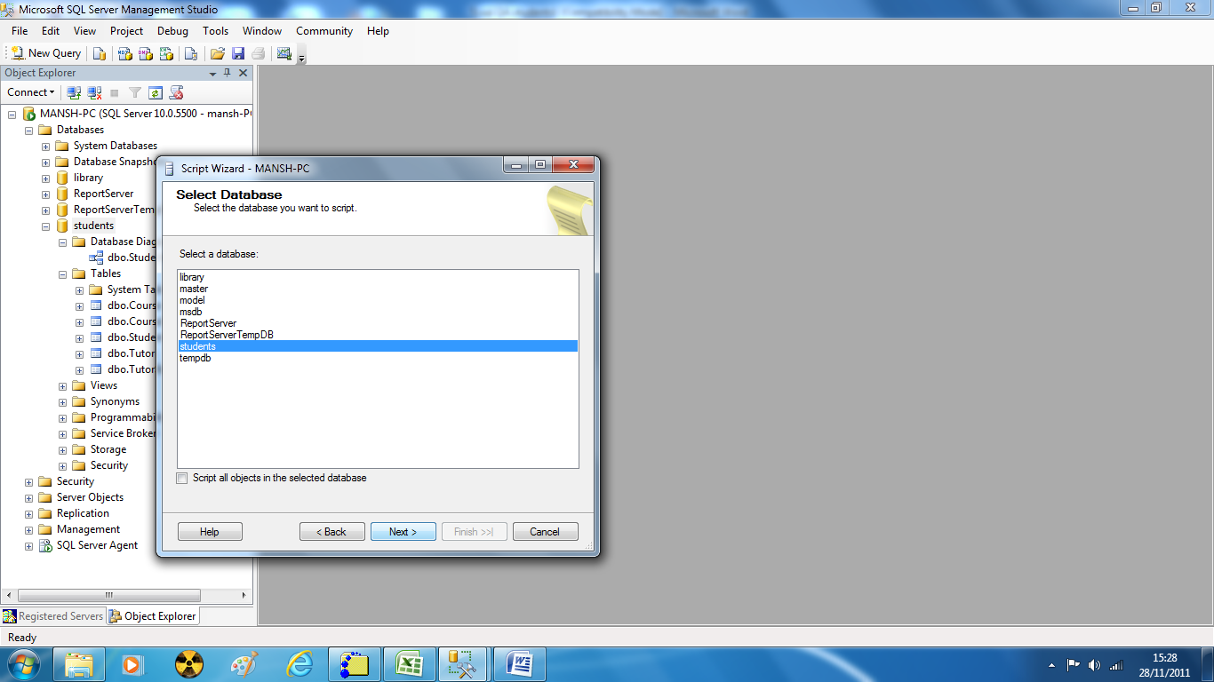

**Step 4 : Select database options –** you may need to click the advance tab depending on the SQL version for the script option menu.

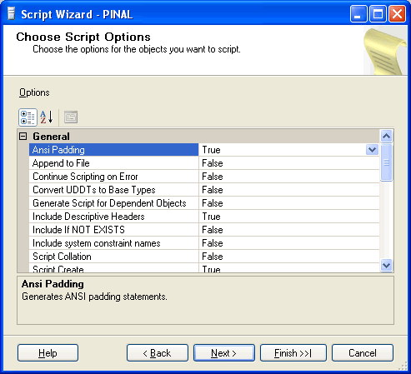

Note you can scroll though the scripting options.

**Script Schema** – to generate the create

**Script Schema and Data** – to generate the create and insert scripts

**Script Drop** – to remove tables from SQL is set to false. Set to true to generate the drop tables.

**Script Data** – to generate the insert scripts for the data is set to false. Set to true if you also want the insert scripts for data to be generated.

The screen below shows script data being set to true

**DIIFERENT VERSIONS**

You are also able to generate script code to different version numbers via the ‘generate script’ task. Note this is useful if you are using SQL Server 2014 at home and SQL Server in the university labs.

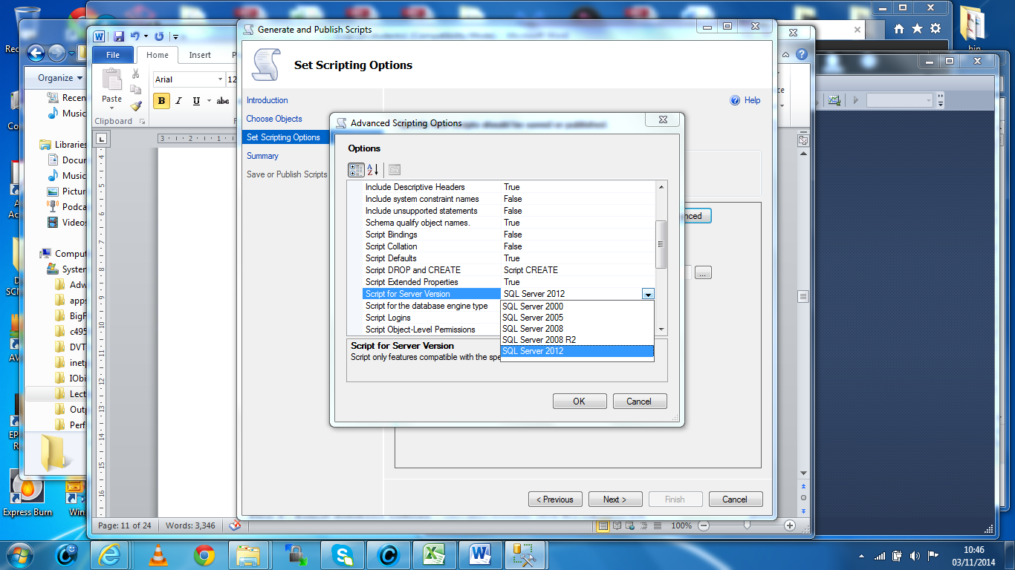

**Step 5 : Select output option**

Check or tick the Tables box

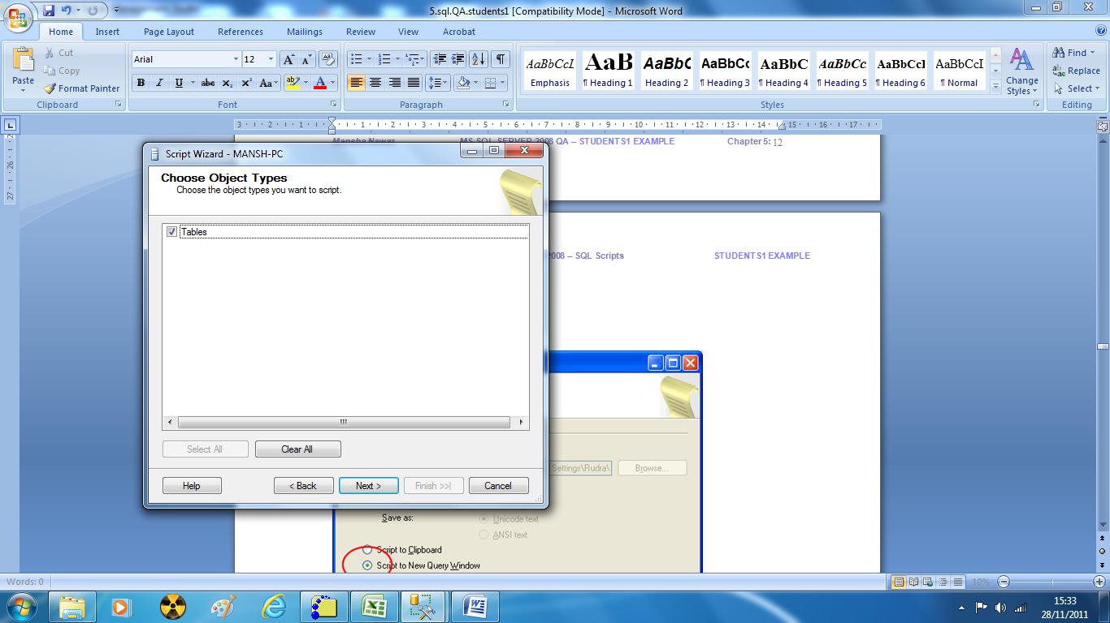

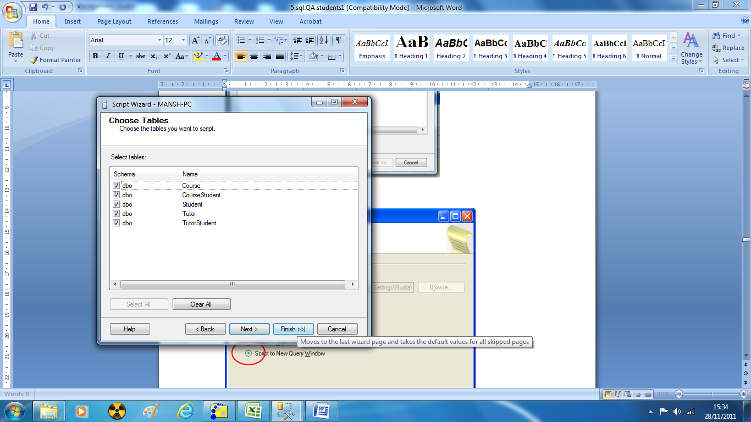

**Step 6 : Review Summary**

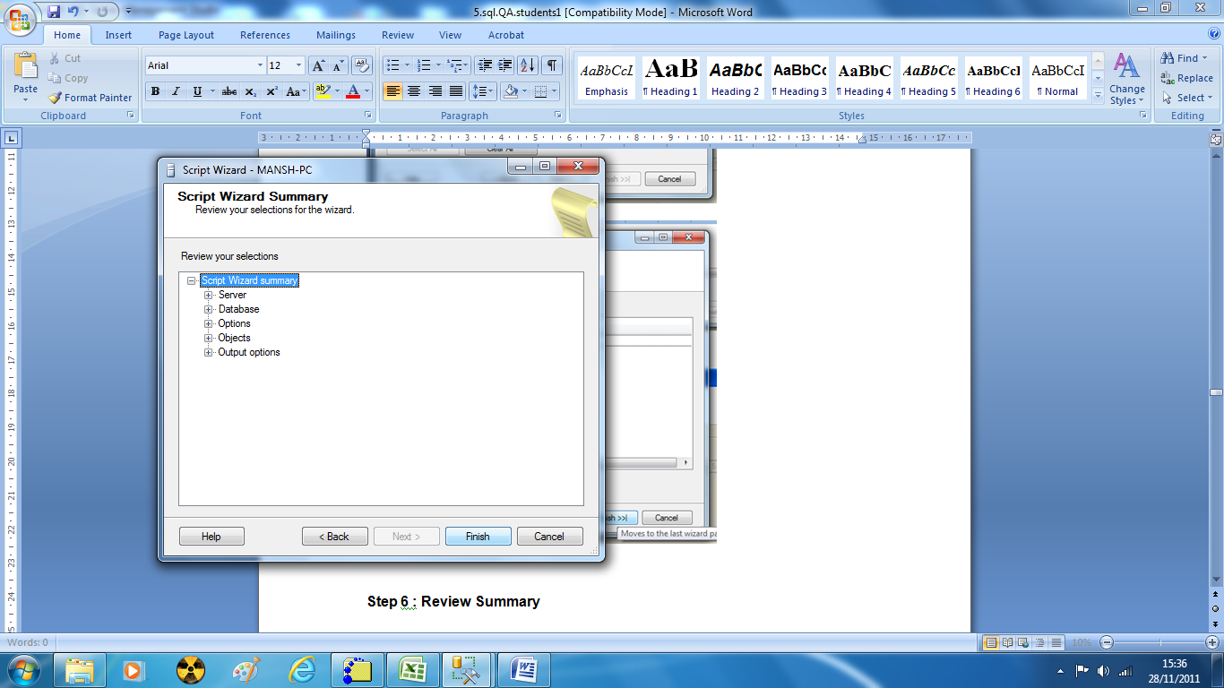

**Step 7 : Observe script generation process**

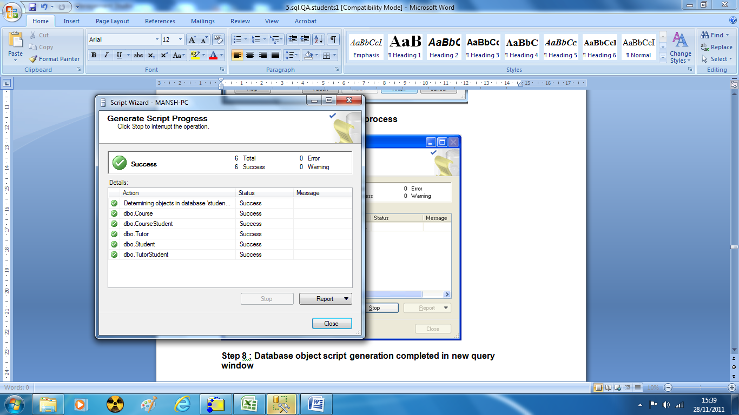

**Step 8 : Database object script generation completed in new query window**

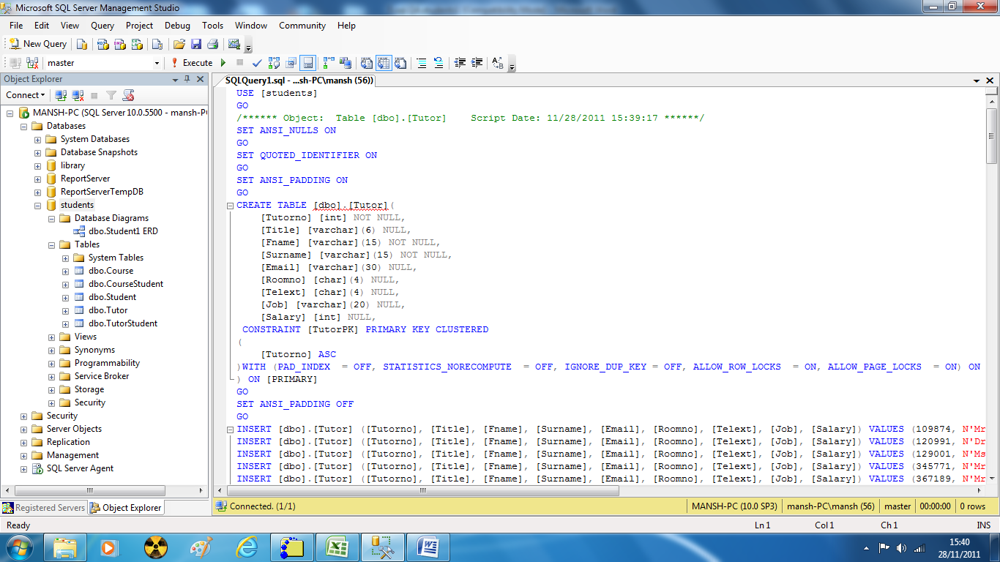

## Using the script code to replicate the database

**NOTE: This is useful and quick way to replicate your database on different machines or maintain different development versions.**

Examine the sql code for the generated create insert script and note the initial code create the database. If the database exists on the host machine then an error will occur and the transaction terminated with no changes. SQL will not let you create a database if it already exists.

Solution 1: **Delete the original database**

1. In Object Explorer, connect to an instance of the SQL Server Database Engine, and then expand that instance.
2. Expand Databases, right-click the database to delete, and then click Delete.
3. Confirm the correct database is selected, and then click OK.

Solution 2:

1. Edit the code (notepad) and find the first ‘**create table**’ command and delete everything prior to this line. Save the file.
2. In Object Explorer, connect to an instance of the SQL Server Database Engine, and then expand that instance.
3. Expand Databases, right-click the database and click New Database. Give it a name
4. Confirm the correct database is selected, and then click OK.
5. In ObjectExplorer click on New Query and copy/paste the revised code. Click on Execute.
6. Right click the database name and click refresh
7. Expand the tables and you will see all the tables have been replicated along with the data if you also have the insert scripts
8. Note you need to recreate the Database Diagrams by adding the tables … SQL will automatically redraw the relationships for you based on the table constraints.